H.T No
Regulations:
A17

Sreenidhi Institute of Science and Technology
(An Autonomous Institution)
Code No: 6A304 Date: 07-July-2021 (FN)
B.Tech II-Year I- Semester Pending External Examination, July - 2021 (Supplementary)
Circuits and Networks-II (EEE)

Time: 3 Hours Max.Marks:75

Note: a) No additional answer sheets will be provided.
b) All sub-parts of a question must be answered at one place only, otherwise it will not be valued.
c) Missing data can be assumed suitably.

ANSWER ANY 5 OUT OF 8 QUESTIONS. EACH QUESTION CARRIES 15 MARKS.

Bloom's Cognitive Levels of Learning (BCLL)

Remember | L1 | Apply | L3 | Evaluate | L5
Understand | L2 | Analyze | L4 | Create | L6

 |  |  | BCLL | CO(s) | Marks
1. | a) | How a three phase power is measured in delta connected load using two watt meters? Explain with a neat sketch. | L2 | CO1 | [8M]
 | b) | The phase impedance of a delta connected load is (15+j20)Ω. What is the line current, if the applied line voltage is 220V? Obtain the amount of power consumed per phase. What is the phasor sum of the three line currents? | L3 | CO1 | [7M]
2. | a) | Derive an expression for the current response in R-L series circuit with a sinusoidal source. | L3 | CO2 | [8M]
 | b) | A direct voltage of 200V is suddenly applied to a series R-L circuit having R=20Ω and inductance L=0.2H. Determine the voltage drop across the inductor at the instant of switching on and at 0.02 sec later. | L3 | CO2 | [7M]
3. | a) | Enumerate the important properties of driving point impedance function of one port passive network. | L4 | CO3 | [8M]
 | b) | Show the pole-zero plot of the given network function V(s) and obtain v(t).  V(s) =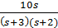 | L4 | CO3 | [7M]
4. | a) | The Z-parameters of the circuit are given by Z₁₁=10Ω, Z₁₂=5Ω, Z₂₁=5Ω and Z₂₂=20Ω. Obtain the transmission parameters. Also find its equivalent T-network. | L3 | CO4 | [8M]
 | b) | Derive relationship between hybrid and Z-parameters of two port network. | L3 | CO4 | [7M]
5. | a) | Briefly explain the important properties of filters. | L2 | CO5 | [8M]
 | b) | Design a T and π section constant-K high pass filter having cut-off frequency of 12kHz and nominal impedance R₀=500Ω. Also find its characteristic impedance and phase constant at 24kHz. | L5 | CO5 | [7M]
6. | a) | Obtain the exponential Fourier series of the wave form shown in below figure  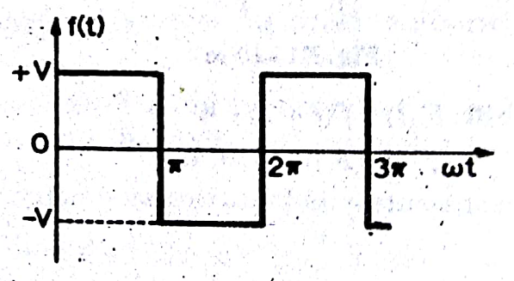 | L3 | CO6 | [8M]
 | b) | Obtain the Fourier coefficients for the function given by  f(t)=(t+π) when – π <t< π; note that f(x+2π)=f(x). | L3 | CO6 | [7M]
7. | a) | The power in a three phase circuit is measured by two wattmeters. If the total power is 50kw, power factor being 0.8 leading, what will be the reading of each wattmeter ? For what power factor will one of the wattmeters read zero ? | L3 | CO1 | [8M]
 | b) | What information do poles and zeros provide in respect of network to which they relate? | L2 | CO2 | [7M]
8. | a) | Obtain the transmission parameters for the circuit shown in below figure.  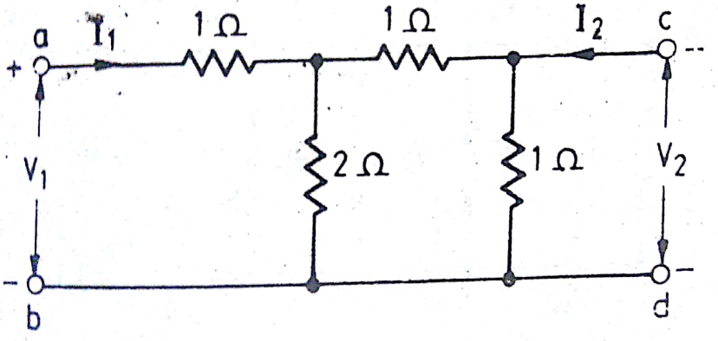 | L3 | CO4 | [8M]
 | b) | What is Fourier transform? Explain any three properties of Fourier transforms. | L2 | CO5 | [7M]

-- 00 -- 00 –

